A WEB-BASED MURANG’A UNIVERSITY HOSTEL ALLOCATION SYSTEM INTEGRATED WITH FINANCE

Maryann Wairimu

A project Proposal Submitted in Partial Fulfillment of the Requirements for the Bachelor of Business in Information Technology of Murang’a University of Technology

December, 2025

DECLARATION
I hereby declare that this proposal is my original work and to the best of my knowledge has not been presented for a degree award in this or any other university
. ……………………………. Date ……………………
Maryann Wairimu
SC232/0366/2022
APPROVAL
The undersigned certify that they have read and hereby recommend for acceptance of Murang’a University of Technology a proposal entitled “A Web-Based Murang’a University of Technology Hostel Allocation System Integrated With Finance”.

…………………………………. Date………………………
Dr. Ndia G. John, PhD
Department of Information Technology
Murang’a University of Technology

ABSTRACT
Web based MUT Hostel Allocation System Integrated with Finance is a paradigm that improves efficiency, transparency, and accessibility in university accommodation processes by automating previously manual operations. At Murang’a University of Technology (MUT), hostel allocation is currently semi-manual, resulting in delays, errors, congestion during booking periods, and challenges in verifying student payments. This study aimed to develop a Web-Based MUT Hostel Allocation System integrated with the Finance Department to provide real-time room availability, streamline room booking, and automate payment confirmation. The objectives were to gather system requirements, analyze existing workflows, design the system architecture, develop the platform, and test its functionality. Data collection methods included questionnaires, interviews, observations, and document review involving students, hostel staff, and finance officers. Ethical considerations such as voluntary participation, confidentiality, informed consent, and secure handling of information were observed throughout the research. The resulting system enhances fairness, reliability, and financial accuracy while improving overall service delivery at MUT.

Table of Contents
DECLARATION ii
ABSTRACT iii
LIST OF TABLES vi
LIST OF FIGURES vii
ACRONYMS AND ABBREVIATIONS viii
CHAPTER ONE: INTRODUCTION 1
1.1 Background of the Study 1
1.2 Statement of the Problem 2
1.3 Objectives of the Study 3
1.3.1 General Objective 3
1.4 Justification of the Study 3
1.5 Scope of the Study 4
CHAPTER TWO: LITERATURE REVIEW 5
2.1 Introduction 5
2.2 Requirements Gathering and Analysis 5
2.2.1 Definition of Techniques 5
2.2.2 Techniques for Requirements Gathering 5
2.2.2.3 Observation 6
2.2.2.4 Document Review 6
2.2.2.5 Focus Groups 6
2.2.3 Techniques for Analysis 6
2.2.3.1 Data Flow Diagrams (DFD) 7
2.2.3.2 Use Case Analysis 7
2.2.3.3 Entity-Relationship Diagrams (ERD) 7
2.2.3.4 SWOT Analysis 7
2.2.3.5 Modeling and Prototyping 7
2.3 System Design Techniques 7
2.3.1 Unified Modeling Language (UML) Diagram 8
2.3.2 Use case Diagram 8
2.3.2 Entity–Relationship Diagram (ERD) 14
2.3.2 Flowchart Diagram 15
2.4 System Development Technologies 17
2.4.1 Technologies and Tools 17
2.4.2 Artificial Intelligence (AI) Algorithms and Databases 18
2.4.3 Frameworks 18
2.5 System Testing 19
2.5.1 Types of System Tests 20
2.6 Existing Similar Systems 21
2.6.1 Discussion of Similar Systems 21
2.7 Chapter Summary 22
CHAPTER THREE: METHODOLOGY 24
3.1 Introduction 24
3.2 Waterfall Methodology 24
3.3 Population and Sampling 25
3.3.1 Sampling Techniques 25
3.4 Data Collection 25
3.4.1 Questionnaires 26
3.4.2 Interviews 26
3.5 System Requirements 26
3.5.1 Software Requirements 26
3.6 Ethical Considerations 27
3.7 Chapter Summary 28
REFERENCES 29
APPENDICES 31
APPENDIX 1: PROJECT BUDGET 31
APPENDIX II: PROJECT SCHEDULE 31
APPENDIX III: QUESTIONNAIRE 32
RE: QUESTIONNAIRE 32
PART A: PERSONAL INFORMATION 32
PART B: CURRENT HOSTEL ALLOCATION PROCESS 33
PART C: PROPOSED WEB-BASED HOSTEL ALLOCATION SYSTEM 33

LIST OF TABLES
Table 2.1 Actors and descriptions 8
Table 2.2 classes and Descriptions 11

LIST OF FIGURES

Figure 2.1 Use Case Diagram 10
Figure 2.2 Class Diagram 13
Figure 2.3 ERD Diagram 14

ACRONYMS AND ABBREVIATIONS
AI – Artificial Intelligence
API – Application Programming Interface
CSS – Cascading Style Sheets
DCS – Directorate of Corporate Services
DBMS – Database Management System
DFD – Data Flow Diagram
ERD – Entity–Relationship Diagram
HTML – Hypertext Markup Language
HTTP – Hypertext Transfer Protocol
ICT – Information and Communication Technology
I/O – Input/Output
JS – JavaScript
KES – Kenya Shillings
LAN – Local Area Network
M-PESA – Mobile Money Payment Service (Safaricom)
MUT – Murang’a University of Technology
MySQL – My Structured Query Language (Database System)
PHP – Hypertext Preprocessor
SDLC – Software Development Life Cycle
SQL – Structured Query Language
SMS – Short Message Service
SSO – Single Sign-On
UI – User Interface
UAT – User Acceptance Testing
UML – Unified Modeling Language
URL – Uniform Resource Locator
WWW – World Wide Web

CHAPTER ONE: INTRODUCTION

1.1 Background of the Study
Access to affordable and convenient accommodation is a critical factor in the academic success and well-being of university students (Brown & Mazzarol, 2018). At Murang’a University of Technology (MUT), hostel allocation plays a central role in ensuring that students have a safe and reliable place to stay while pursuing their studies. However, the process of allocating hostel spaces has traditionally been handled through manual or semi-manual methods, which often lead to inefficiencies, delays, errors, and cases of dissatisfaction among students (Karanja & Mwangi, 2020). Such challenges highlight the need for a more transparent, efficient, and user-friendly approach to hostel management.
A web-based application refers to software that is hosted on a server and accessed through a web browser, allowing users to interact with it without the need for installation on personal devices. Such applications have gained popularity due to their accessibility, scalability, and ability to deliver real-time services (Pressman & Maxim, 2020). Hostels, on the other hand, are residential facilities provided by educational institutions to cater for the accommodation needs of students. They form an essential part of student welfare by reducing the stress of finding housing and providing a secure and affordable living environment (Omondi & Wanyama, 2019).
In recent years, the global adoption of web-based applications has transformed how services are delivered across industries. Universities, in particular, have increasingly embraced online platforms for services such as student registration, fee payment, library management, and e-learning (Ssekakubo, Suleman & Marsden, 2019). These trends demonstrate the growing recognition of technology as a tool for improving efficiency, transparency, and service delivery.
To better understand the value of such a system, one can draw a comparison to the transportation industry. For instance, bus companies like Mash Poa have revolutionized how travelers book their trips from Mombasa to Nairobi and vice versa. Instead of physically queuing at bus stations to secure a seat, passengers can now conveniently book the seat of their choice from the comfort of their homes. This model has reduced congestion, minimized errors, and enhanced customer satisfaction (Singh & Patel, 2021). Similarly, a web-based hostel allocation system can allow students to easily apply for hostels, view available options, and receive fair allocations without the need for physical presence or lengthy administrative processes.
Beyond basic allocation, the proposed system will go a step further by enabling students to visualize the hostels and rooms available before making their choice. Just as travelers select their preferred seats on a bus or airplane, students will be able to view hostel layouts, check room occupancy status in real time, and choose their desired room. This approach enhances transparency, gives students greater control, and reduces the uncertainty that often surrounds hostel allocation.
The advantages of hostel allocation systems supported by web technology include efficiency, transparency, reduced paperwork, real-time updates, improved record management, and enhanced student satisfaction (Wambugu & Chege, 2020). Such systems not only benefit students by easing their accommodation process but also support university administrators in monitoring occupancy, planning resources, and ensuring fairness in allocation.
The general issue, therefore, lies in the gap between the growing student population and the limited efficiency of manual hostel allocation methods (Ngugi & Kimani, 2021). This study proposes the design and development of a web-based hostel allocation system for MUT, aimed at improving convenience, fairness, and operational efficiency in managing student accommodation, while also introducing visualized room selection for a more student-friendly experience.

1.2 Statement of the Problem
At Murang’a University of Technology (MUT), the process of allocating hostels is semi-manual and not supported by a modern web-based system (Karanja & Mwangi, 2020). This causes many challenges such as delays, lack of fairness, and high workload for administrators. Without an online system, students are often left with confusion about room availability and allocation results. The absence of a secure, reliable, and intelligent platform creates room for errors, congestion during booking periods, and sometimes misuse of resources.
The problem also extends to key areas of technology. In terms of security, manual records or simple systems can be accessed or altered without proper controls (Pressman & Maxim, 2020). Usability is low since students cannot easily view or book rooms from their devices. Functionality is limited because the current methods do not provide features such as visualizing hostels or real-time updates. Reliability is a challenge because manual methods often lead to double-bookings or lost records. Intelligence is also missing since the system does not analyze or suggest better ways of allocating rooms fairly.
Although there are a few existing hostel management systems used in other institutions, most of them face similar limitations. First, many lack strong security measures to protect student data (Wambugu & Chege, 2020). Second, some are not fully web-based, meaning students must still visit offices physically or rely on offline processes. Third, most do not allow room visualization, leaving students unable to see which specific rooms they are applying for. These gaps show the need for a more advanced, student-friendly, and reliable web-based hostel allocation system for MUT.

1.3 Objectives of the Study

1.3.1 General Objective
To develop a web-based hostel allocation system for Murang’a University of Technology (MUT). For the purpose of improving on security, efficiency, usability, reliability, and transparency in hostel allocation.
1.3.2 Specific Objectives
i. To gather requirements for the web-based hostel allocation system.
ii. To analyze the requirements for the web-based hostel allocation system.
iii. To design the web-based hostel allocation system.
iv. To develop the web-based hostel allocation system for Murang’a University of Technology (MUT).
v. To validate (test) the web-based hostel allocation system for Murang’a University of Technology.

1.4 Justification of the Study
This study is necessary because hostel allocation at Murang’a University of Technology (MUT) is semi-manual, which causes problems such as delays, unfair allocations, confusion, and lack of transparency (Ngugi & Kimani, 2021). With the increasing number of students, these challenges will only grow if no proper solution is introduced. A modern and reliable system is therefore needed to make the hostel booking process more efficient and user-friendly.
The proposed web-based hostel allocation system provides several solutions. First, it will improve security by protecting student information and allocation records (Pressman & Maxim, 2020). Second, it will improve efficiency by reducing paperwork, saving time, and making the process faster. Third, it will improve usability by allowing students to view hostels and choose rooms online at their convenience. Fourth, it will increase reliability by avoiding errors such as double-booking and lost records. Lastly, it will add transparency and fairness since all students will use the same platform and see real-time updates (Ssekakubo et al., 2019).
By providing these solutions, the system will benefit both students and university management. Students will enjoy a simpler, fairer, and stress-free way of getting accommodation, while administrators will be able to manage hostels more effectively.

1.5 Scope of the Study
This study focuses on the design and development of a web-based hostel allocation system for Murang’a University of Technology (MUT). The system specifically aims to manage hostel booking by allowing students to view available hostels, check room availability, and select rooms of their choice online. To make the process simple and user-friendly, the system will use color codes to show the status of each room: green for empty rooms, yellow for booked rooms, and red for occupied rooms (Singh & Patel, 2021). It also provides administrators with tools to manage student data, track occupancy, and ensure fairness in allocation.The scope of this study is limited to hostel allocation within MUT. It does not cover other services such as payment integration, external accommodation outside the university, or hostel maintenance management. The main boundary of this project is to provide a secure, reliable, and user-friendly platform that deals only with student hostel allocation.Through this study, the aim is to improve the efficiency of the allocation process, enhance transparency and fairness, and strengthen security and reliability of student records. The project also seeks to improve the usability of the process by enabling students to access the system anytime and anywhere, thus reducing delays and confusion that are common in manual hostel allocation (Wambugu & Chege, 2020).

CHAPTER TWO: LITERATURE REVIEW

2.1 Introduction
Chapter One highlighted that Murang’a University of Technology (MUT) currently uses a semi-manual hostel allocation process, which, although functional, can be improved through automation and integration with the university’s finance department. The proposed web-based hostel allocation system seeks to enhance efficiency, transparency, and user convenience by allowing students to view available rooms, select hostels, and make direct payments through a linked finance module. Research shows that automating university systems increases service delivery, minimizes errors, and saves administrative time (Kumar & Singh, 2022), while integrating finance systems improves accountability and simplifies fee tracking (Mwangi, Otieno, & Wanjiru, 2021). Several East African universities have already adopted similar approaches for example, the University of Nairobi uses the Hostel Allocation and Management Information System (HAMIS) for online room booking (University of Nairobi, 2024), Makerere University employs a semi-automated hostel booking system to ease student accommodation (Makerere University, 2023), and the University of Dar es Salaam integrates its accommodation portal with financial services to enable direct payment for hostels (University of Dar es Salaam, 2022). This chapter therefore reviews existing literature and related systems to explore how such technologies can be adapted and improved for MUT.

2.2 Requirements Gathering and Analysis
Requirements gathering and analysis are essential stages in system development as they identify what the system should do and how it should operate. According to Pressman (2020), these processes ensure the final product meets user needs and delivers value. For this project, understanding the requirements of students, administrators, and the finance department is crucial to ensure smooth hostel allocation and seamless financial integration.

2.2.1 Definition of Techniques
Techniques are structured methods or procedures used in system development to achieve specific goals efficiently. In the context of the MUT Hostel Allocation System integrated with Finance, techniques help developers gather, organize, and interpret requirements from users, ensuring that the final system meets both accommodation and payment needs accurately. According to Dennis, Wixom, and Tegarden (2019), techniques guide analysts in translating user needs into clear, testable, and implementable specifications. Therefore, these approaches help ensure quality, accuracy, and consistency throughout the software development process.

2.2.2 Techniques for Requirements Gathering
Requirements gathering techniques help developers understand user expectations, challenges in the current semi-manual hostel allocation process, and the overall system goals. For the MUT Hostel Allocation System, these techniques ensure that both user requirements (students, finance officers, hostel administrators) and system requirements are collected accurately. The following techniques are essential:
2.2.2.1 Interviews
This involves conducting direct discussions with hostel managers, finance officers, and students to gain insights into how the current allocation and payment processes work. Interviews help in understanding user frustrations, preferred features, and any operational challenges that the new system should address.
2.2.2.2 Questionnaires
Questionnaires are distributed to students to gather feedback on their room selection preferences, satisfaction with the current system, and expectations for the new automated process. This method enables collecting data from a large group within a short time.

2.2.2.3 Observation
This technique involves monitoring and analyzing the current semi-manual allocation and finance procedures. By observing staff and students during room booking, allocation, and payment confirmation steps, the development team identifies inefficiencies, delays, and areas needing improvement.

2.2.2.4 Document Review
Document review includes examining existing hostel records, student accommodation forms, payment reports, and university finance guidelines. These documents help developers understand existing workflows, business rules, data structures, and compliance requirements.

2.2.2.5 Focus Groups
This involves engaging a small group of students and staff to discuss system expectations, preferred features, and usability concerns. Focus groups encourage shared problem-solving and help validate requirements gathered from interviews, questionnaires, and observations.

According to Sommerville (2015), combining these techniques ensures that both functional (booking, payment, room management) and non-functional (security, usability) requirements are well understood.

2.2.3 Techniques for Analysis
After gathering the requirements, analysis techniques are applied to refine, validate, and structure them to ensure feasibility and remove redundancy. For the MUT Hostel Allocation System, these techniques help determine how core processes such as room booking, payment validation, and record updating will interact within the system. The following analysis techniques are commonly used:

2.2.3.1 Data Flow Diagrams (DFD)
DFDs are used to illustrate how data flows between users and departments. This includes showing how students submit room booking requests, how hostel administrators process them, and how payment information is verified by the finance department. DFDs help visualize the movement of data and highlight any bottlenecks in the current process.

2.2.3.2 Use Case Analysis
Use case analysis focuses on modelling how different users students, administrators, and finance officers interact with the system. This technique helps define system boundaries, identify major functions, and understand user intentions, such as booking a room, validating payments, or generating reports.

2.2.3.3 Entity-Relationship Diagrams (ERD)
ERDs define the relationships between entities involved in hostel allocation, including students, rooms, bookings, and payments. This technique helps in understanding how data is stored, linked, and retrieved, forming the foundation for designing the system database.

2.2.3.4 SWOT Analysis
SWOT analysis helps evaluate the overall system environment by identifying its strengths, weaknesses, opportunities, and threats. For the MUT Hostel Allocation System, strengths include automation and efficiency; weaknesses may involve dependency on internet connectivity; opportunities include system integration with finance; and threats may involve risks such as data breaches or cyber-attacks.

2.2.3.5 Modeling and Prototyping
This technique involves creating early visual representations of the system’s interface, particularly focusing on room selection pages, booking forms, and payment sections. Prototypes help stakeholders visualize the system, provide feedback, and refine usability before development begins.
As noted by Pressman and Maxim (2020), these analysis techniques ensure clarity, improve design accuracy, and support the development of reliable and efficient systems.

2.3 System Design Techniques
System design techniques are methods and tools used to visually represent how a system will function, its structure, data flow, and how users interact with it. These models provide a blueprint that guides developers during implementation and ensures all components of the system are well understood before coding begins.
According to Shelly and Rosenblatt (2017), design techniques enhance clarity, minimize design errors, and help developers plan effective system workflows.
For the MUT web-based hostel allocation system, the following techniques are applied:

2.3.1 Unified Modeling Language (UML) Diagram
The UML diagram is a standardized modeling approach used to describe and visualize system components, their relationships, and interactions. UML provides different diagram types such as class, use case, and component diagrams that help in showing both the structural and behavioral aspects of a system.
In the hostel allocation system:
The student, admin, and finance officer are key actors interacting with the system.
System components include modules such as Room Management, Booking and Allocation, and Payment Integration.
UML helps visualize how these components connect, communicate, and depend on each other.

2.3.2 Use case Diagram
A Use Case Diagram is a type of UML (Unified Modeling Language) diagram that visually represents the functional requirements of a system. It shows the interactions between users (actors) and the system, highlighting the services or actions the system provides. Use case diagrams are important for understanding the scope of the system and the relationship between users and system functions.
Actors
Actors represent users or external systems that interact with the system. In this project, the main actors include:
Table 2.1 Actors and descriptions
Actor | Description / Role
Student | Requests hostel allocation, makes payments, and views allocation status.
Admin Staff | Reviews applications, approves or rejects applications, assigns rooms.
Finance Officer | Verifies payments and issues receipts.
Security Personnel | Validates student check-in/check-out and monitors occupancy.
SIS / ERP System | Provides student information and supports verification of enrollment and payment.
Bank Payment Gateway | Processes payments securely for hostel fees.
Email/SMS Service | Sends notifications to students and staff regarding booking and payment updates.
Use Cases
Use cases represent the main functions or services the system offers. Key use cases in the system include:
- Student Use Cases:
Request Hostel
Make Payment
View Allocation Status
- Admin Staff Use Cases:
Review Applications
Approve/Reject Applications
Assign Room / Approve Room
- Finance Officer Use Cases:
Verify Payment
Issue Receipt
- Security / External Systems:
Validate Entry / Monitor Occupancy (Security)
Send Notification (Email/SMS Service)
Data synchronization and verification with SIS/ERP System
Payment verification via Bank Payment Gateway
- Interactions
Students interact directly with the system to request rooms and make payments.
Admin Staff manages applications and room allocations.
Finance Officer processes payments and issues receipts.
Security Personnel interacts with the system to ensure room check-ins are valid and occupancy is monitored.
External systems such as SIS/ERP and Bank Gateway are integrated with the system for data verification and secure payment processing.
Email/SMS Service provides notifications to students and staff.

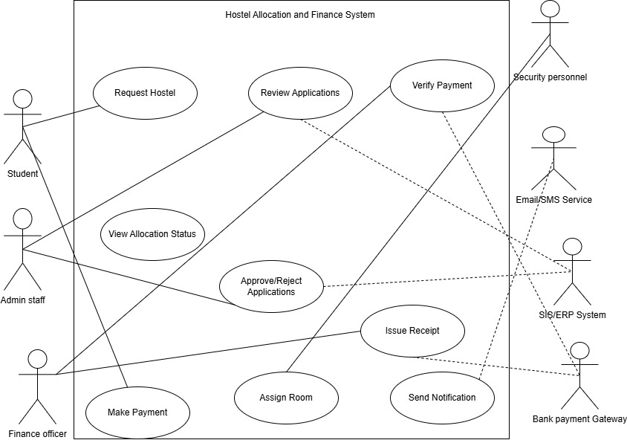
Figure 2.1 Use Case Diagram

2.3.3 Class Diagram
A Class Diagram is a type of UML (Unified Modeling Language) diagram that illustrates the static structure of a system. It shows classes, their attributes, methods, and the relationships between them. Class diagrams are important for modeling data organization, object interactions, and how different parts of a system relate.For the MUT Hostel Allocation & Finance System, the Class Diagram captures students, hostel rooms, payments, administrators, and integrated finance and external systems, providing a clear view of the system’s architecture.

Table 2.2 classes and Descriptions
Classes and Descriptions
Class | Attributes |  | Methods / Operations | Description
Student | studentID, name, email |  | requestHostel(), makePayment(), viewStatus() | Represents students applying for hostel rooms and making payments.
Admin | adminID, name |  | approveApplication(), assignRoom() | Manages hostel applications and room allocations.
Finance | financeID, name |  | verifyPayment(), issueReceipt() | Handles payment verification and issuing receipts.
Hostel | hostelID, name, totalRooms |  | checkAvailability() | Represents hostel buildings containing rooms.
Room | roomID, roomNumber, capacity, occupancy |  | checkAvailability(), assignStudent() | Represents individual rooms in hostels and student assignments.
Payment | paymentID, amount, date, status |  | processPayment(), generateInvoice() | Handles payment transactions for hostel bookings.
BankGateway | bankName, accountNumber |  | validatePayment() | External system for secure payment processing.
ERPSystem | systemName |  | verifyStudent() | External system for validating student information.

Relationships
Student → Room: A student is assigned to a room.
Room → Hostel: A hostel contains multiple rooms.
Admin → Room / Student: Admin assigns rooms and approves applications.
Student → Payment: Student makes payments.
Finance → BankGateway: Finance verifies payments through the bank.
Admin → ERPSystem: Admin verifies student data via ERP.
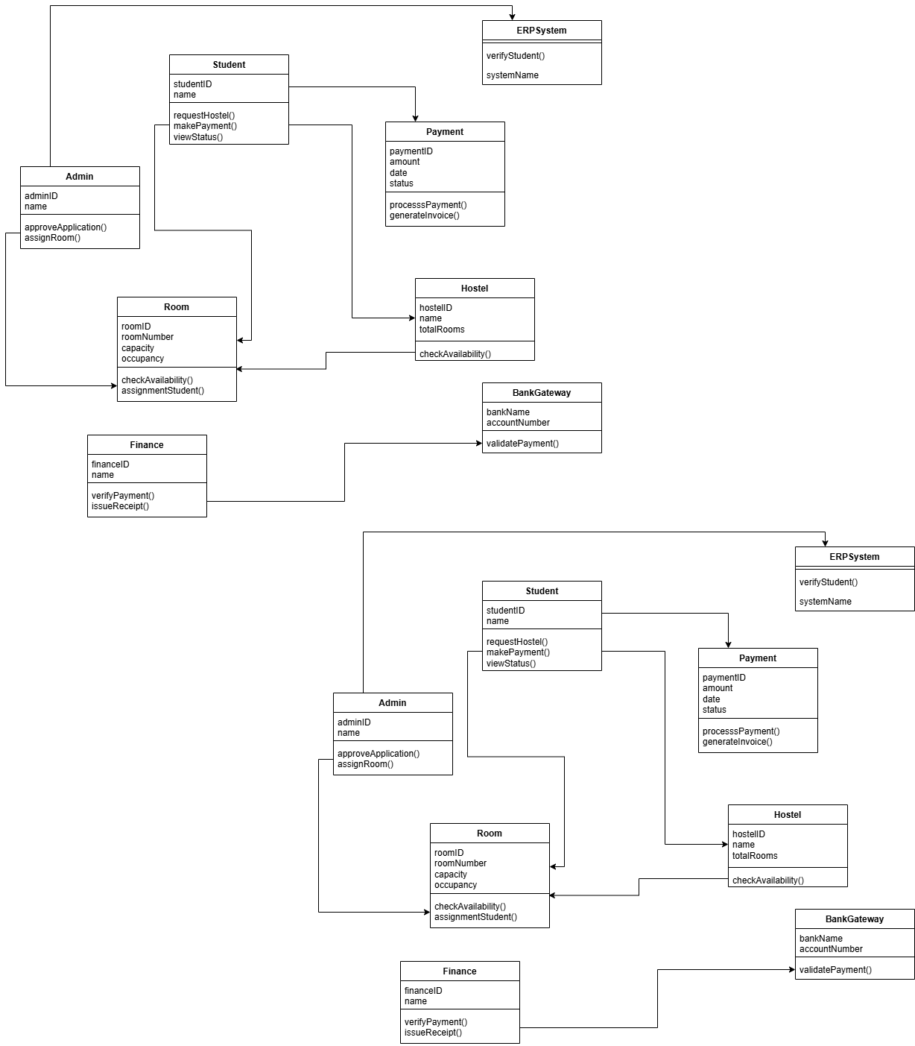
Figure 2.2 Class Diagram
According to Booch, Rumbaugh, and Jacobson (2015), UML diagrams standardize communication among developers and make system architecture easy to understand.

2.3.2 Entity–Relationship Diagram (ERD)
An Entity–Relationship Diagram (ERD) represents the logical structure of a database by showing entities (tables), their attributes (fields), and relationships between them. It is essential for designing the database that supports the system.
In the MUT hostel allocation system:
Key entities include Student, Room, Booking, and Payment.
Relationships show how data connects, for example:
A student books one or more rooms.
Each booking has one payment record.
Rooms belong to a hostel block.
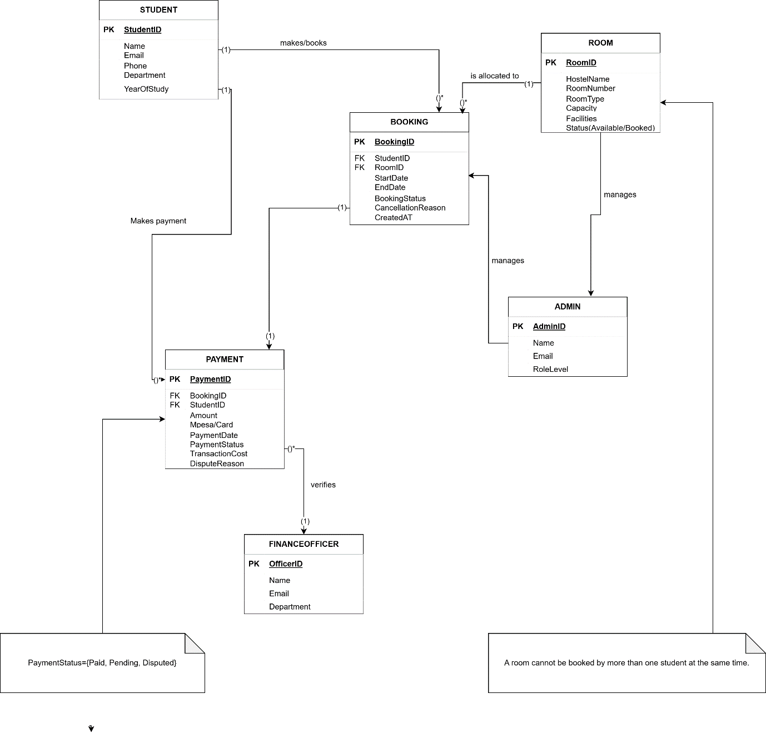
Figure 2.3 ERD Diagram
According to Pressman and Maxim (2020), ERDs help ensure data integrity, reduce redundancy, and provide a clear foundation for database implementation.
Example use: Displaying how student booking data links with payment and room details within the database.

2.3.2 Flowchart Diagram
A Flowchart is a graphical representation that shows the step-by-step flow of processes or operations within a system. It uses symbols such as rectangles (processes), diamonds (decisions), and arrows (flow direction) to represent logical sequences.
For the hostel allocation system, a flowchart can illustrate:
- How students register and log in.
- How available rooms are checked and selected.
- How payments are processed through the finance module.
- How confirmations and receipts are generated.
Common symbols used:
Oval – Start/End of the process.
Rectangle – Process or action e.g.Verify Payment.
Diamond – Decision point e.g.Is Room Available?
Arrow – Flow direction between steps.
Parallelogram – Input/Output e.g.Enter Student Details

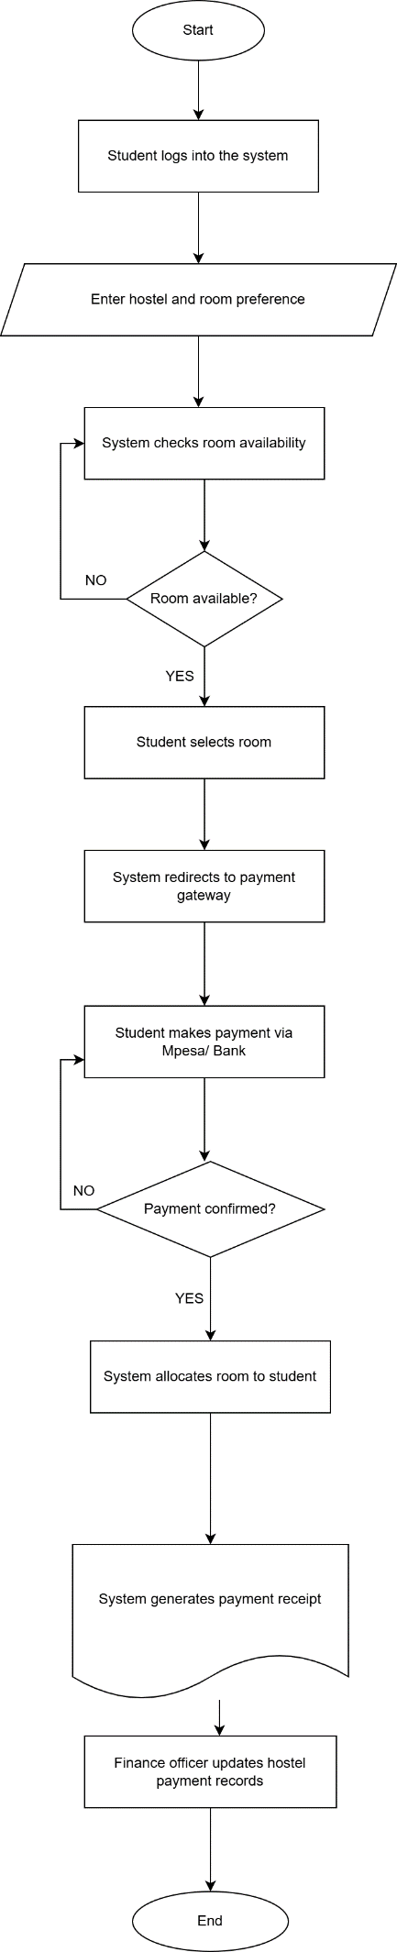
Figure 2.4 Flowchart Diagram
According to Sommerville (2015), flowcharts help in identifying redundant steps, improving system efficiency, and simplifying implementation.

2.4 System Development Technologies
System development technologies refer to the tools, frameworks, programming languages, and artificial intelligence algorithms used to design and implement a web-based system. For this project, these technologies will support the design and development of a web-based hostel allocation system for Murang’a University of Technology (MUT) that is inconjoined with the university’s Finance Department. This integration ensures that students can easily pay their hostel fees online, and the system can automatically verify payments, confirm room bookings, and update financial records in real time. The technologies discussed below help make the system secure, efficient, user-friendly, and transparent for both students and administrators.

2.4.1 Technologies and Tools
To develop the web-based hostel allocation system, several technologies and tools are applied at different stages of development:
1. Frontend Technologies
These create the interface students and administrators interact with.
i. HTML5: Builds the web page structure.
ii. CSS3: Styles and formats layouts, colors, and fonts.
iii. JavaScript: Adds interactivity such as form validation and live room status updates.
iv. React.js or Angular: Enhance responsiveness and user experience through dynamic pages.
2. Backend Technologies
Handle logic, data processing, and communication between the frontend and database.
i. PHP: A server-side scripting language that powers dynamic systems.
ii. Python (Django/Flask): Provides security and scalability in backend logic.
iii. Node.js: Manages multiple requests efficiently, supporting live data updates.
3. Database Technologies
Store and manage data such as student details, payments, and room allocations.
i. MySQL: Reliable for structured storage.
ii. PostgreSQL: Offers advanced queries and ensures data consistency.
iii. MongoDB: Stores unstructured and real-time data effectively.
4. Payment Integration Tools
Since the system is integrated with the Finance Department, it will use APIs like M-Pesa Daraja API, PayPal, or Stripe to allow students to pay hostel fees directly through the platform. Once a payment is confirmed, the system will automatically mark the student’s allocation as active and update both the hostel and finance records instantly.

5. Security Technologies
i. SSL/TLS Encryption: Secures data between client and server.
ii. JWT (JSON Web Tokens): Ensures safe login and user authentication.
iii. Firewalls and Data Validation: Protect the system from unauthorized access.
6. Development Tools
i. Visual Studio Code / PyCharm: Used for coding and debugging.
ii. GitHub: For version control and collaboration.
iii. XAMPP/WAMP: For local testing and deployment setup.
(According to Kumar & Raj, 2023, combining modern web technologies like JavaScript, PHP, and MySQL improves system performance and user satisfaction in institutional platforms.)

2.4.2 Artificial Intelligence (AI) Algorithms and Databases
Artificial Intelligence (AI) plays an important role in automating decision-making during hostel allocation. It can analyze data from student applications and payments to make fair and efficient allocations.
Support Vector Machine (SVM): Used to predict student accommodation preferences and automatically allocate rooms based on history and room availability (Omondi et al., 2022).
Decision Trees: Help the system decide how to allocate rooms fairly among students.
K-Means Clustering: Groups students by year, gender, or faculty for fair distribution of rooms.
Rule-Based Systems: Apply logical rules (e.g., “first-year students get priority”) to guide allocation.
Neural Networks: Analyze booking patterns and predict periods of high hostel demand.
Databases such as MySQL and MongoDB will store the data used by these algorithms, including student records, hostel information, and transaction histories. The link with the finance module allows the AI to ensure that only paid bookings are confirmed.
According to Singh & Patel, 2021, integrating AI with database systems increases automation, reduces human error, and enhances efficiency in institutional management platforms.

2.4.3 Frameworks
Frameworks provide developers with structured tools and reusable components for creating secure, scalable, and maintainable systems. For the MUT hostel allocation system integrated with finance, both frontend and backend frameworks will be used.
1. Frontend Frameworks
i. React.js: Enables real-time updates (e.g., room status changes) without page reloads (Sharma & Gupta, 2023).
ii. Angular: Provides structured, two-way data binding for dynamic user interfaces.
iii. Bootstrap: Ensures a mobile-friendly and responsive design.
2. Backend Frameworks
i. Django (Python): Comes with built-in authentication, security, and database management (Omondi et al., 2022).
ii. Laravel (PHP): Uses MVC architecture and integrates easily with M-Pesa APIs for direct financial transactions.
iii. Express.js (Node.js): Supports real-time operations and quick responses for booking confirmation after payment.
3. Full-Stack Frameworks
i. MEAN Stack (MongoDB, Express.js, Angular, Node.js): Ideal for building interactive, real-time systems.
ii. MERN Stack (MongoDB, Express.js, React.js, Node.js): Offers flexibility and seamless finance-module integration.
4. Testing Frameworks
i. Jest and Mocha: Test frontend components.
ii. PyTest (for Django) and PHPUnit (for Laravel): Verify backend functions like payment validation and room allocation logic.
Using these frameworks ensures that the system not only manages hostel allocations efficiently but also integrates finance-related processes like fee confirmation and transaction verification in a secure and transparent way.
Singh & Patel, 2021, emphasize that using strong frameworks improves maintainability, reliability, and security in web-based applications.

2.5 System Testing
System testing is a critical phase in software development that ensures the entire system works as expected before deployment. It verifies that all components including the hostel allocation module and the finance integration module function together correctly to deliver accurate, reliable, and secure results. Testing also helps identify and correct any errors, performance issues, or integration problems that may occur between modules such as user registration, payment processing, and hostel allocation. According to Kumar & Sharma (2022), systematic testing enhances software reliability, reduces maintenance costs, and improves user satisfaction.

2.5.1 Types of System Tests
Several testing techniques will be applied to ensure the MUT Hostel Allocation System performs optimally:
i. Black Box Testing
This technique focuses on testing the functionality of the system without examining the internal code structure. Testers input data and observe the output to check if it meets expected results.
As stated by Singh & Patel, 2021, black box testing ensures functional accuracy and user satisfaction
ii. White Box Testing
This method involves testing the internal workings of the system. Developers check logic, loops, and code structure to ensure that each function executes properly.
iii. Integration Testing
Integration testing ensures that different modules of the system work together smoothly. Since this project combines hostel allocation and financial transactions, integration testing will confirm that data flows correctly between the two.(Omondi et al., 2022, highlight that integration testing is vital in systems involving multiple connected modules
iv. System Testing
This test checks the entire system as a whole to ensure that all requirements are met. It validates both functional and non-functional aspects such as usability, performance, and security.
v. User Acceptance Testing (UAT)
UAT involves end users such as students and hostel administrators who test the system to confirm it meets their needs.
(According to Sharma & Gupta, 2023, user acceptance testing ensures that the system aligns with real-world user expectations.)
vi. Performance Testing
This testing evaluates how the system performs under heavy load conditions. It checks speed, stability, and responsiveness.
vii. Security Testing
Since the system involves financial transactions, this testing ensures data protection, payment security, and user privacy.
(As noted by Raj & Kaur, 2023, security testing is essential for systems involving sensitive financial and personal data.)
viii. Regression Testing
Regression testing is done after system updates or bug fixes to ensure that new changes do not break existing features.
Through these tests, the MUT Hostel Allocation System integrated with Finance will be verified for accuracy, security, and user efficiency. The testing process ensures smooth payment integration, reliable data synchronization, and error-free hostel assignment, ultimately enhancing both student experience and institutional efficiency.

2.6 Existing Similar Systems
Several web-based hostel and accommodation management systems have been developed in universities and institutions across East Africa and beyond. These systems share a common goal of automating hostel allocation, improving record management, and simplifying the booking process. However, most still have gaps in full financial integration, user visualization, and scalability areas the proposed MUT Hostel Allocation System integrated with Finance aims to address.

2.6.1 Discussion of Similar Systems
University of Nairobi Hostel Management System (Kenya)
The University of Nairobi developed an online platform that allows students to apply for hostels, view available rooms, and receive allocation updates.
Limitation: The system lacks complete financial integration; students must still make separate payments through bank or mobile money channels, delaying automatic room confirmations (University of Nairobi ICT Directorate, 2021).
Kenyatta University Hostel Booking System (Kenya)
This system enables students to reserve rooms online and provides updates on available spaces each semester.
Limitation: It does not include visual room layouts, making it hard for students to choose preferred rooms or understand room occupancy in real time (Kenyatta University ICT Department, 2020).
Makerere University Accommodation System (Uganda)
Makerere University’s hostel system automates housing registration and record management for both on- and off-campus accommodation.
Limitation: The system has limited automation in report generation and lacks direct financial integration, requiring manual verification between finance and accommodation offices (Luyinda et al., 2021).
University of Lagos Hostel Allocation Portal (Nigeria)
The University of Lagos implemented a digital system that supports online hostel allocation and integrates with external payment gateways.
Limitation: The system occasionally experiences downtime during high-demand periods such as semester openings, affecting performance and scalability (Akinyemi & Okonkwo, 2022).
Strathmore University Accommodation Portal (Kenya)
Strathmore University provides an online hostel management system for students to apply for on-campus accommodation and manage personal data.
Limitation: It lacks a color-coded visual interface to display room status (available, booked, or occupied), which can make navigation and decision-making slower for students (Strathmore University ICT Centre, 2021).

Although these systems have enhanced hostel allocation processes in various universities, many still face limitations such as weak financial integration, lack of real-time visualization, and low system scalability. The proposed MUT Hostel Allocation System integrated with Finance seeks to overcome these weaknesses by:
Introducing real-time financial integration for instant payment confirmation and allocation.
Implementing color-coded visual room selection :green for available, yellow/orange for booked, and red for occupied.
Ensuring high reliability and scalability to handle large student traffic during allocation periods.
These improvements will enhance transparency, efficiency, and convenience in the hostel booking and payment experience for MUT students.

2.7 Chapter Summary
This chapter presented a comprehensive review of literature related to the development of a web-based hostel allocation system integrated with finance. It began by discussing the importance of effective hostel management and how web-based systems have improved efficiency, transparency, and accessibility in universities. The chapter further outlined the processes of requirements gathering and analysis, highlighting various techniques such as interviews, questionnaires, and document analysis that help developers understand user and system needs. It also explored system design techniques like UML, ERD and Flowchart diagrams, which guide the structure and interaction of the proposed system.
Additionally, system development technologies and frameworks were discussed, including programming tools like HTML, CSS, JavaScript, PHP, Python, MySQL, and frameworks such as Django and Laravel. The section also covered artificial intelligence algorithms such as Support Vector Machines (SVM) for intelligent analysis and decision-making, and the importance of database systems for managing records efficiently. System testing approaches such as black-box, white-box, and user acceptance testing were also highlighted as crucial for ensuring reliability and performance.
The review of existing systems, such as those used by the University of Nairobi, Kenyatta University, Makerere University, Karatina University, and JKUAT, revealed several gaps. While these systems improve hostel allocation processes, they still face limitations such as:
Lack of full financial integration, which slows down payment confirmations and room bookings.
Absence of real-time room visualization, preventing students from easily identifying available or occupied rooms.
Limited automation and interactivity, especially in systems still using semi-manual methods for allocation and record verification.
To address these gaps, the proposed MUT Hostel Allocation System integrated with Finance aims to provide a fully interactive, real-time, and financially integrated platform. It will offer visualized room selection, secure payment integration, and color-coded room status indicators; green for available, yellow/orange for booked, and red for occupied. This system will therefore enhance efficiency, reliability, and transparency in hostel allocation within Murang’a University of Technology.

CHAPTER THREE: METHODOLOGY

3.1 Introduction
This chapter will present the research methodology that will be used in developing the Web-Based MUT Hostel Allocation System integrated with Finance. It explains the approach that will guide the design, data collection, and system development processes. In this chapter, the reader should expect a detailed explanation of the research design, data collection methods, sampling techniques, data analysis procedures, and the system development methodology that will be applied throughout the project.

3.2 Waterfall Methodology
The project will adopt the Waterfall Methodology, which is a structured and sequential model where each phase must be completed before moving to the next. The model will be suitable for the Web-Based MUT Hostel Allocation System integrated with Finance because the project requirements are clearly defined and require a logical flow from analysis to implementation (Pressman & Maxim, 2020).
The methodology will consist of the following phases:
- Requirements Analysis – The researcher will gather information on the existing hostel allocation and finance processes using questionnaires and observation.
- System Design – The system’s architecture, database schema, and data flow diagrams will be created based on the analyzed requirements.
- Implementation – The system will be developed using PHP, MySQL, Laravel, Bootstrap, HTML, CSS, and JavaScript.
- Testing – Unit and integration tests will be conducted to ensure that all modules function as expected.
- Deployment and Maintenance – The final system will be installed, and users will be trained to ensure effective operation.
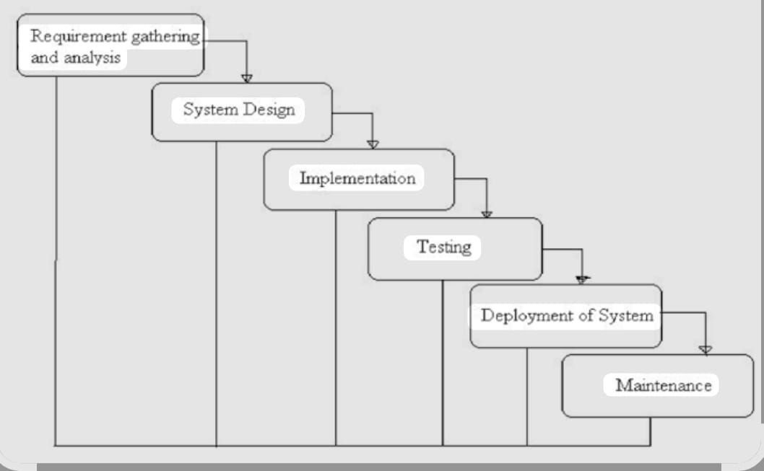
FIGURE 3.4
According to Sommerville (2016), the Waterfall model ensures order and reliability by emphasizing documentation and verification at every stage.

3.3 Population and Sampling
The study population will consist of MUT students, hostel administrators, and finance officers, since these are the main stakeholders who interact with hostel allocation and payment processes. Collecting data from these groups will ensure that the system will meet the needs of all intended users (Creswell, 2014).

3.3.1 Sampling Techniques
The study will use Stratified Random Sampling and Convenience Sampling.
Stratified Random Sampling will ensure that respondents are selected from distinct groups such as students, hostel officers, and finance officers to provide balanced feedback.
Convenience Sampling will be applied to include respondents who will be easily available and willing to participate during the data collection process (Kothari, 2014).
These techniques will help ensure that relevant and representative information will be obtained for the system design and development.

3.4 Data Collection
Data collection will focus on obtaining accurate and relevant information that will support the design of the Web-Based MUT Hostel Allocation System integrated with Finance. Both primary and secondary data sources will be used. Primary data will be gathered through questionnaires and observation, while secondary data will be obtained from institutional reports, books, and online resources on hostel and finance management systems (Creswell, 2014).

3.4.1 Questionnaires
Structured and semi-structured questionnaires will be administered to students, hostel officers, and finance staff to identify challenges in the current allocation and payment processes. According to Kothari (2014), questionnaires provide a reliable and efficient method of collecting large amounts of data within a short time. The responses will help the researcher determine the key user requirements and desired system features.

3.4.2 Interviews
Interviews will be used to collect information about the actual hostel allocation and financial procedures currently practiced at MUT. This method will help obtain firsthand insights, clarify processes, and understand challenges experienced by students, hostel officers, and finance staff. According to Creswell (2014), interviews allow a researcher to gather detailed, real-world perspectives and experiences that support the design of practical systems.The study will use semi-structured interviews, which allow the researcher to follow a set of guiding questions while giving participants the freedom to provide detailed and open-ended responses.

3.5 System Requirements
System requirements will define the minimum specifications necessary to design, develop, and operate the Web-Based MUT Hostel Allocation System integrated with Finance. These requirements will ensure stable performance, data security, and cross-platform accessibility (Pressman & Maxim, 2020).

3.5.1 Software Requirements
The Web-Based MUT Hostel Allocation System integrated with Finance will use the following minimum software requirements to ensure efficiency, compatibility, and security during development and deployment:
Operating System: Windows 10 or Linux Ubuntu
Web Server: Apache (via XAMPP)
Database Management System: MySQL
Programming Languages: PHP, HTML, CSS, and JavaScript

Frameworks:
a) Laravel – for structured and secure backend development
b) Bootstrap – for responsive and clean user interface design
c) jQuery – for adding interactivity and dynamic functionality
Development Tools: Visual Studio Code, PHPMyAdmin
Web Browser: Google Chrome or Mozilla Firefox
These technologies provide a robust environment for developing a secure, responsive, and user-friendly system that supports both hostel allocation and financial transaction modules.
According to Pressman and Maxim (2020), these technologies will provide scalability, security, and effective web integration with financial processes.
3.5.2 Hardware Requirements
The minimum hardware specifications will include:
Server Requirements
Processor: Intel Core i3 or higher
RAM: 4 GB or above
Hard Disk: 250 GB
Internet Connection: Minimum 5 M
Client (User) Requirements
Processor: Intel Core i3 or equivalent
RAM: 2 GB
Storage: 50 GB
Device: Desktop, laptop, or smartphone with a stable internet connection
These requirements will ensure that the system runs smoothly, supports concurrent users, and allows reliable integration with finance modules (Sommerville, 2016).

3.6 Ethical Considerations
The study will adhere to ethical research principles to ensure respect, transparency, and confidentiality. Participants will be informed about the purpose of the research and will voluntarily give consent before participating. Data collected will be kept confidential and will be used solely for academic and system development purposes.
According to Creswell (2014), ethical research ensures that participant rights are protected and data is used responsibly. The researcher will also ensure proper citation of all sources and adherence to ethical software engineering practices, such as safeguarding user data and avoiding plagiarism (Kothari, 2014).

3.7 Chapter Summary
This chapter outlines the research methodology that will be used to develop the Web-Based MUT Hostel Allocation System integrated with Finance. It describes the Waterfall model as the research design, the target population, sampling techniques, data collection methods, system requirements, and ethical considerations. The next chapter will present System Design and Implementation, which will describe the architecture, diagrams, and system modules of the proposed system.

REFERENCES
Brown, R., & Mazzarol, T. (2018). Student accommodation and academic success. Journal of Higher Education Policy and Management, 40(2), 120–135.
Karanja, D., & Mwangi, M. (2020). Challenges of manual student accommodation systems in Kenyan universities. International Journal of Information Systems, 5(1), 45–53.
Ngugi, P., & Kimani, S. (2021). Factors affecting the efficiency of university accommodation processes in Kenya. African Journal of Education and Technology, 12(3), 23–32.
Omondi, L., & Wanyama, F. (2019). Student housing and welfare in higher learning institutions in East Africa. Education Research Review, 14(4), 112–125.
Pressman, R. S., & Maxim, B. (2020). Software engineering: A practitioner’s approach (9th ed.). McGraw-Hill.
Singh, A., & Patel, R. (2021). The role of web-based systems in enhancing university service delivery. International Journal of Computer Applications, 174(32), 1–7.
Ssekakubo, G., Suleman, H., & Marsden, G. (2019). ICT adoption in universities: A case study of digital transformation. Computers & Education, 128, 105–114.
Wambugu, J., & Chege, P. (2020). Analysis of hostel management systems in Kenyan universities. Journal of ICT Research and Development, 9(2), 55–70. Creswell, J. W. (2014). Research Design: Qualitative, Quantitative, and Mixed Methods Approaches (4th ed.). SAGE Publications.
Kothari, C. R. (2014). Research Methodology: Methods and Techniques (4th ed.). New Age International Publishers.
Pressman, R. S., & Maxim, B. R. (2020). Software Engineering: A Practitioner’s Approach (9th ed.). McGraw-Hill Education.
Sommerville, I. (2016). Software Engineering (10th ed.). Pearson Education.
Kumar, R., & Singh, A. (2022). Automation and Efficiency in University Management Systems. Journal of Information Systems and Technology, 9(3), 44–52.
Mwangi, P., Otieno, C., & Wanjiru, L. (2021). Integration of Financial Modules in Web-Based University Systems. International Journal of Computing and ICT Research, 15(2), 112–119.
University of Nairobi. (2024). Hostel Allocation and Management Information System (HAMIS). Retrieved from https://www.uonbi.ac.ke
Makerere University. (2023). Online Student Accommodation Booking System. Retrieved from https://www.mak.ac.ug
University of Dar es Salaam. (2022). Accommodation and Finance Integration Portal. Retrieved from https://www.udsm.ac.tz
Dennis, A., Wixom, B. H., & Tegarden, D. (2019). Systems Analysis and Design: An Object-Oriented Approach with UML (6th ed.). Wiley.
Pressman, R. S., & Maxim, B. R. (2020). Software Engineering: A Practitioner’s Approach (9th ed.). McGraw-Hill Education.
Sommerville, I. (2015). Software Engineering (10th ed.). Pearson Education Limited.
Kumar, P., & Sharma, R. (2022). Software Testing Principles and Practices. International Journal of Computer Science Studies, 11(2), 33–41.
Omondi, J., Mwangi, E., & Njoroge, P. (2022). Enhancing Efficiency in Web-Based Applications Using Django and AI Integration. Journal of Software Engineering Research, 9(3), 60–69.
Raj, M., & Kaur, G. (2023). Security Testing for Financial Web Applications. International Journal of Information Security Studies, 10(1), 77–85.
Sharma, K., & Gupta, V. (2023). Evaluating the Role of User Acceptance Testing in Web System Development. International Journal of Information Technology, 8(2), 32–40.
Singh, R., & Patel, D. (2021). Integration of AI Algorithms in Web-Based Database Systems. International Journal of Emerging Technologies, 15(1), 89–97.
Akinyemi, T., & Okonkwo, U. (2022). Digital transformation of student accommodation systems in Nigerian universities. Journal of Information Systems and Technology, 14(2), 45–54.
Kenyatta University ICT Department. (2020). Kenyatta University Online Hostel Booking System Manual. Nairobi, Kenya.
Luyinda, J., Nabunya, R., & Odoi, P. (2021). Automation of hostel management systems in higher learning institutions: A case study of Makerere University. Makerere University Press.
Strathmore University ICT Centre. (2021). Accommodation Portal User Guide. Nairobi, Kenya.
University of Nairobi ICT Directorate. (2021). University of Nairobi Hostel Management Platform Overview. Nairobi, Kenya.
Creswell, J. W. (2014). Research Design: Qualitative, Quantitative, and Mixed Methods Approaches (4th ed.). SAGE Publications.
Kothari, C. R. (2014). Research Methodology: Methods and Techniques (4th ed.). New Age International Publishers.
Pressman, R. S., & Maxim, B. R. (2020). Software Engineering: A Practitioner’s Approach (9th ed.). McGraw-Hill Education.
Sommerville, I. (2016). Software Engineering (10th ed.). Pearson Education

APPENDICES

APPENDIX 1: PROJECT BUDGET
S/No. | ITEM | COST (Ksh.)
1. | Laptop | 75,000
2. | Internet and data bundles | 1,800
3. | Software tools | 1,500
4. | Questionnaire tokens | 300
5. | Stationery | 250
6. | Documentation | 1,150
 | TOTAL COST | 80,000

APPENDIX II: PROJECT SCHEDULE
Activity | week  1 | week  2 | week  3 | week  4 | week  5 | week  6 | week  7 | week  8 | week  9 | Week 10 | Week 11 | Week 12
Requirement gathering
Requirement Analysis
System
Design
System
Development
System
Validation

APPENDIX III: QUESTIONNAIRE
Maryann Wairimu
SC232/0366/2022
Murang’a University of Technology
Department of Information Technology
P.O. Box 75–10200
Kenya.
Dear Madam/Sir,
RE: QUESTIONNAIRE
I am pursuing a Bachelor of Business Information Technology at the School of Computing, Department of Information Technology, Murang’a University of Technology. I am currently conducting a research project titled “A Web Based MUT Hostel Allocation System Integrated with Finance.”
The objective of this study is to investigate the challenges in the current hostel allocation process and gather user requirements necessary for developing an efficient, automated, and finance-integrated hostel allocation system for MUT.
Your participation as an expert/respondent will greatly contribute to the achievement of the research objectives by providing insights, experiences, and opinions regarding the current system and the proposed solution.
Kindly note that all the information collected will be treated with strict confidentiality and will be used solely for academic purposes.
Your cooperation and participation are highly valued and appreciated.
Sincerely Yours,
Maryann Wairimu
NB: PLEASE SELECT THE APPROPRIATE BOX BY TICKING

PART A: PERSONAL INFORMATION
Gender
[ ] Male
[ ] Female
Your Role/Category
[ ] Student
[ ] Hostel Department Staff
[ ] Finance Department Staff
[ ] ICT Staff
[ ] Other (Specify): ______________________
How long have you been interacting with the hostel allocation process?
[ ] Less than 1 year
[ ] 1–2 years
[ ] 3–4 years
[ ] Over 4 years

PART B: CURRENT HOSTEL ALLOCATION PROCESS
How would you rate the current hostel allocation process?
[ ] Very Efficient
[ ] Efficient
[ ] Neutral
[ ] Inefficient
[ ] Very Inefficient
What challenges have you experienced with the current hostel allocation method? (Tick all that apply)
[ ] Delays in allocation
[ ] Errors in manual processing
[ ] Lack of transparency
[ ] Difficulty verifying payments
[ ] Overcrowding during physical allocation
[ ] Others (Specify): ________________________
Do you think integrating finance (payment verification) would improve the allocation process?
[ ] Yes
[ ] No
[ ] Not Sure

PART C: PROPOSED WEB-BASED HOSTEL ALLOCATION SYSTEM
Which features do you consider important for the proposed system?
[ ] Online room booking
[ ] Real-time room availability
[ ] Automatic M-Pesa payment verification
[ ] User accounts (login)
[ ] Notifications (SMS/Email)
[ ] Dashboard for hostel and finance officers
[ ] Other (Specify): _________________________

How user-friendly should the system interface be?
[ ] Very User-Friendly
[ ] User-Friendly
[ ] Neutral
[ ] Difficult
[ ] Very Difficult
Would you recommend the adoption of the proposed system at MUT?
[ ] Yes
[ ] No
[ ] Maybe
Any additional comments or recommendations?

